**SILENT EXTRACTOR EXHAUST FANS:**

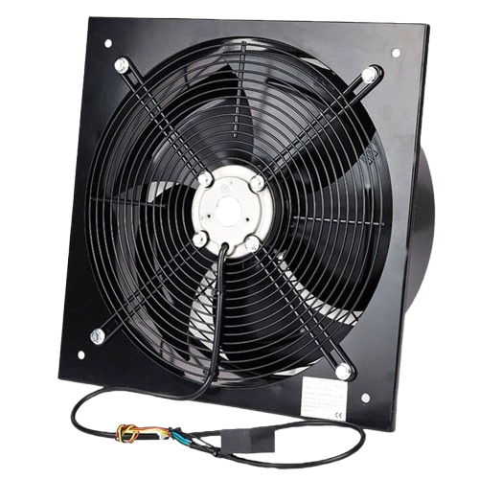

**Price: 4,900.00**

The Extractor Exhaust Fan is a high-performance ventilation solution, designed to efficiently remove fumes, dust, and pollutants from industrial, commercial, and residential spaces. With its powerful motor and aerodynamically designed blades, this fan delivers exceptional airflow capacity, making it ideal for applications requiring heavy-duty ventilation, such as factories, laboratories, and workshops. Its durable construction, corrosion-resistant coating, and easy installation ensure reliable performance and low maintenance requirements.

**Key features of silent extractor exhaust fans include:**

* **Effective Air Extraction:** Removes smoke, odors, and pollutants for improved air quality.
* **Powerful Performance:** Provides strong ventilation for efficient air movement.
* **Durable Construction:** Made with corrosion-resistant and long-lasting materials.
* **Energy Efficient:** Consumes less power while ensuring optimal performance.
* **Quiet Operation:** Minimizes noise during operation for a more comfortable environment.
* **Compact Design:** Space-saving and easy to install in tight spaces.
* **Versatile Use:** Suitable for kitchens, bathrooms, or industrial spaces.